CONFIDENTIAL CS/NOV 2026/MAT133

UNIVERSITI TEKNOLOGI MARA FINAL EXAMINATION

COURSE
COURSE CODE
EXAMINATION TIME
PRE CALCULUS
MAT133 NOVEMBER 2026
2 HOURS

INSTRUCTIONS TO CANDIDATES

- This question paper consists of 3 questions.

- Answer ALL questions in the Answer Booklet. Start each answer on a new page.

- Do not bring any material into the examination room unless permission is given by the invigilator .
- Please check to make sure that this examination pack consists of: i) the Question Paper
  - a one - page Append ix 1
  - an Answer Booklet - provided by the Faculty
  - a graph paper - provided by the Faculty

- Answer ALL questions in English.

/

DO NOT TURN THIS PAGE UNTIL YOU ARE TOLD TO DO SO

This examination paper consists of 7 printed pages

QUESTION 1
a) Find the equation of the straight line passing through (0, -5) and (-2, 4).
(4 marks)
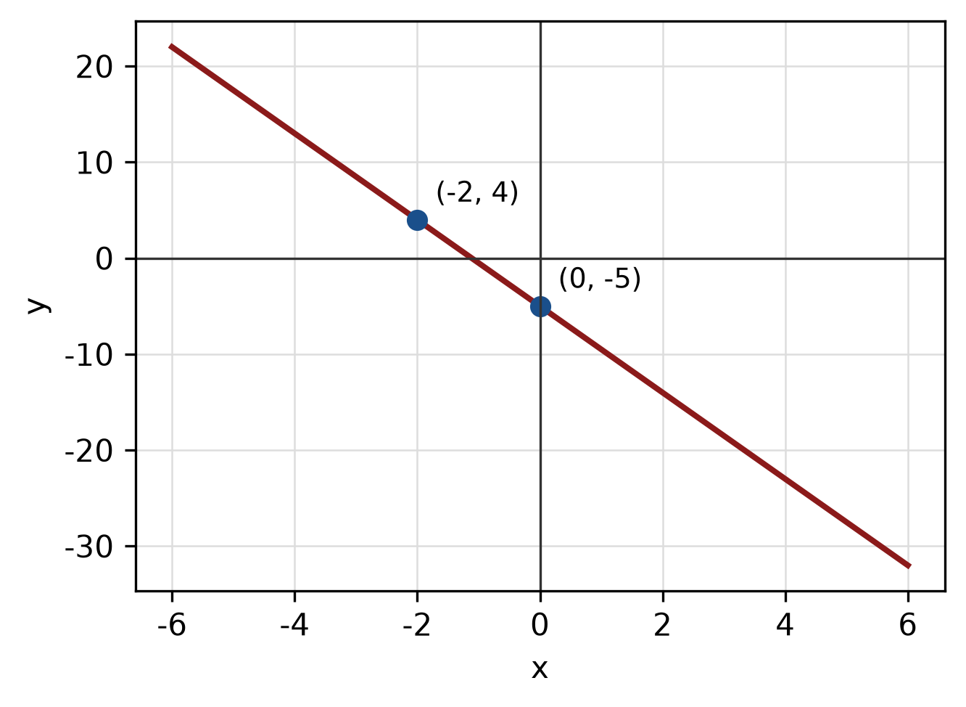
Figure: line through the two points.
b) Find the equation of the line passing through (-2, 1) and parallel to the line -4x + 5y + 3 = 0.
(5 marks)
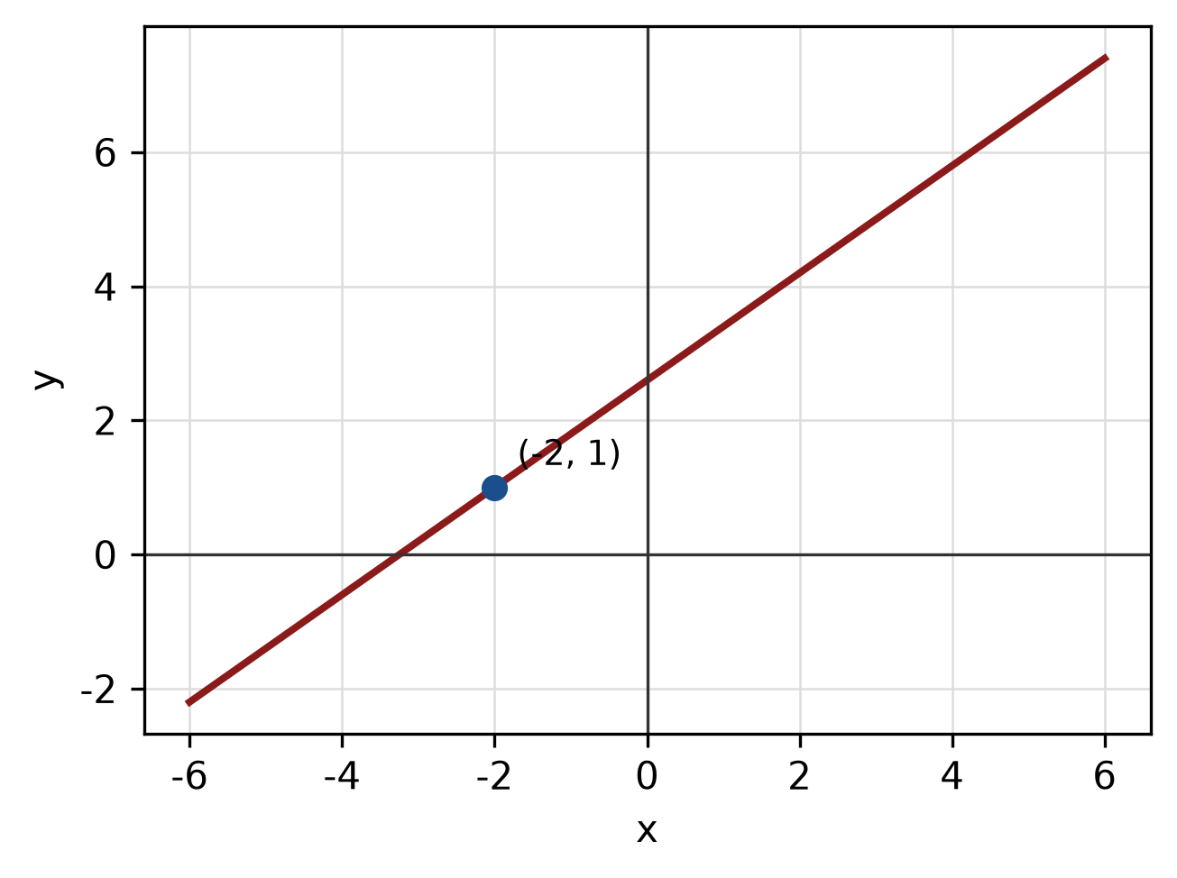
Figure: required line.
c) Find the equation of the line with x-intercept 8 and y-intercept -8.
(4 marks)
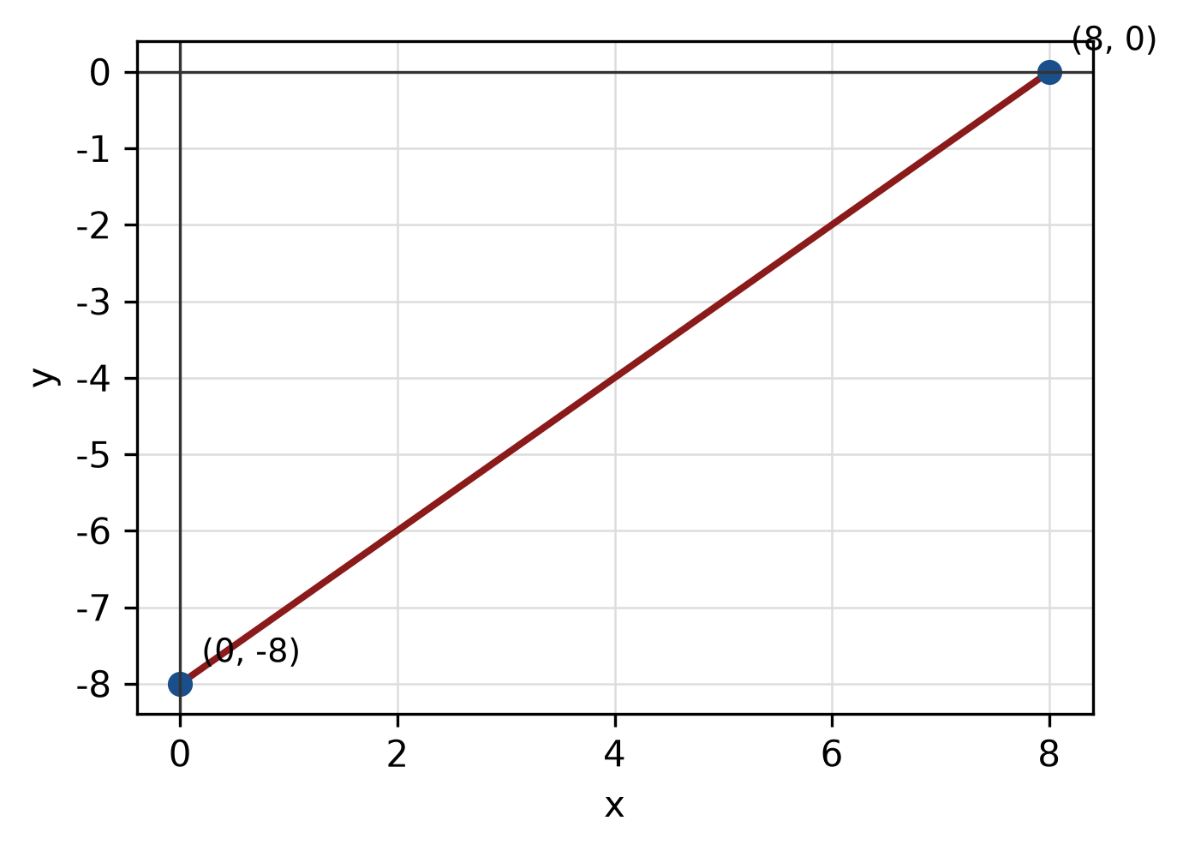
Figure: line and intercepts.
QUESTION 2
a) Write the equation of the circle with centre (-5, 4) and radius 3. Hence write its general equation and sketch the circle.
(5 marks)
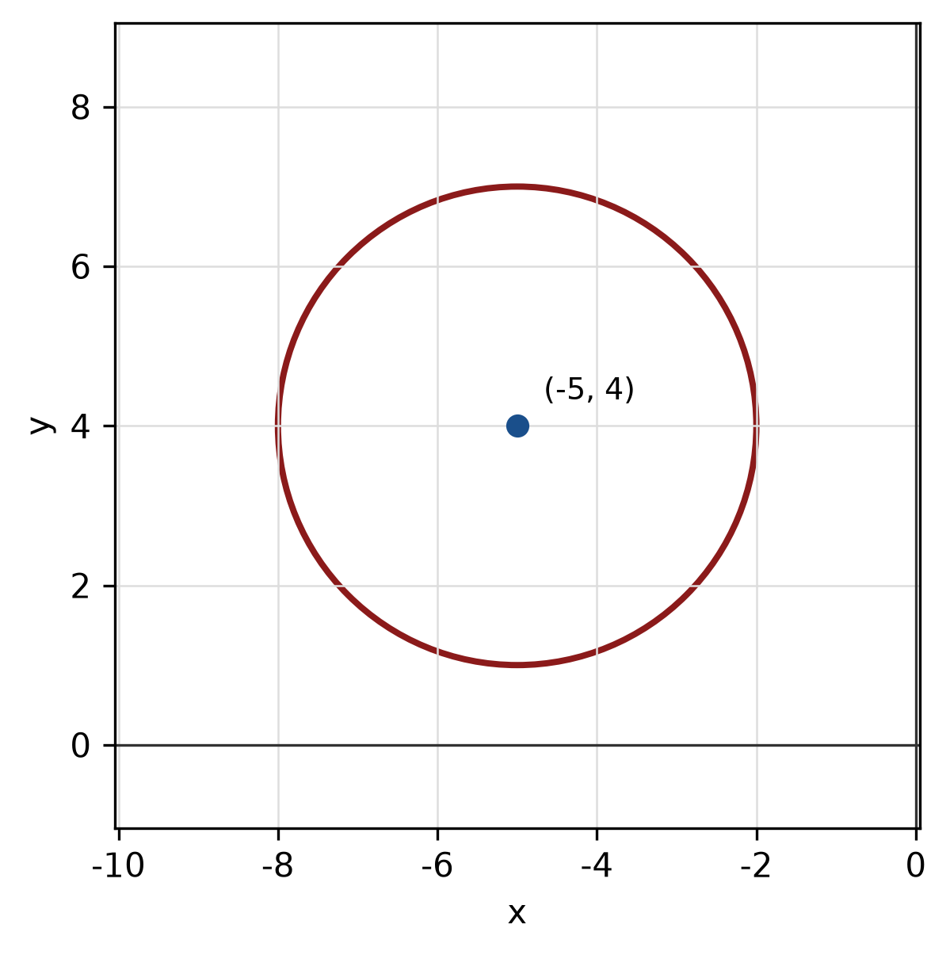
Figure: circle.
b) Write x² + 8x + y² - 10y + 25 = 0 in standard form. Hence state the centre and radius and sketch the circle.
(5 marks)
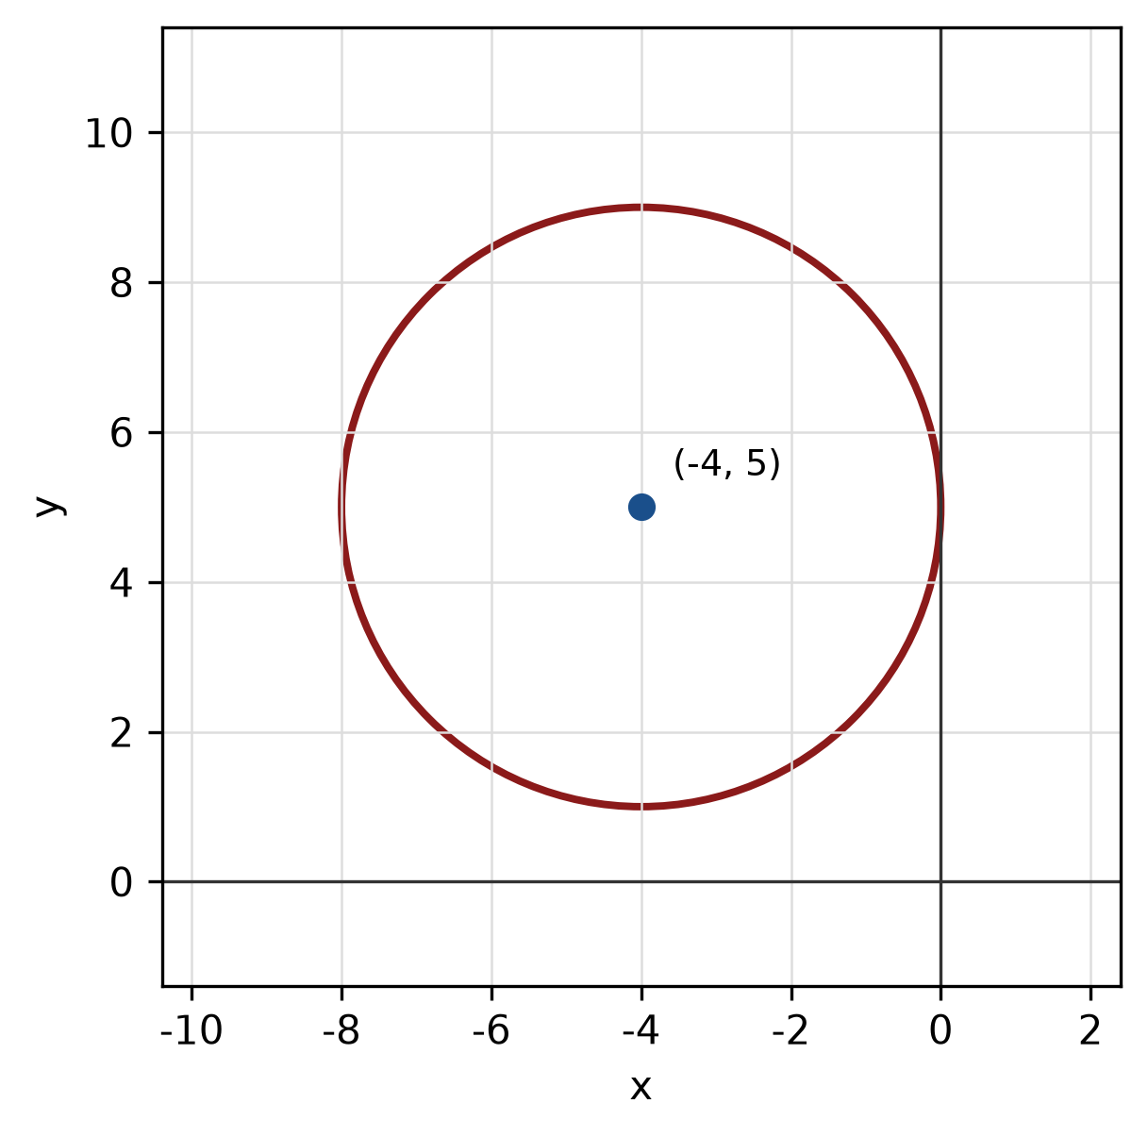
Figure: circle.
c) The endpoints of a diameter of a circle are (2, 2) and (-6, -5). Find the centre, radius and equation of the circle.
(5 marks)
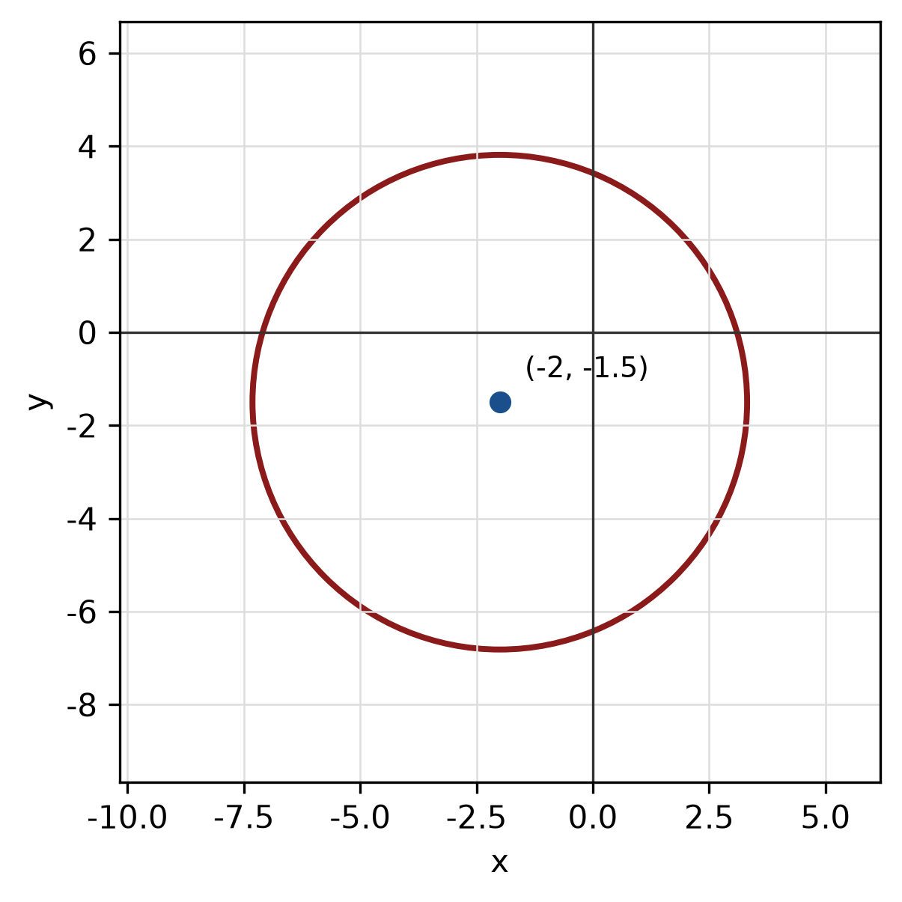
Figure: circle from diameter.
d) Sketch the circle x² - 10x + y² + 8y - 8 = 0. State its centre and radius.
(4 marks)
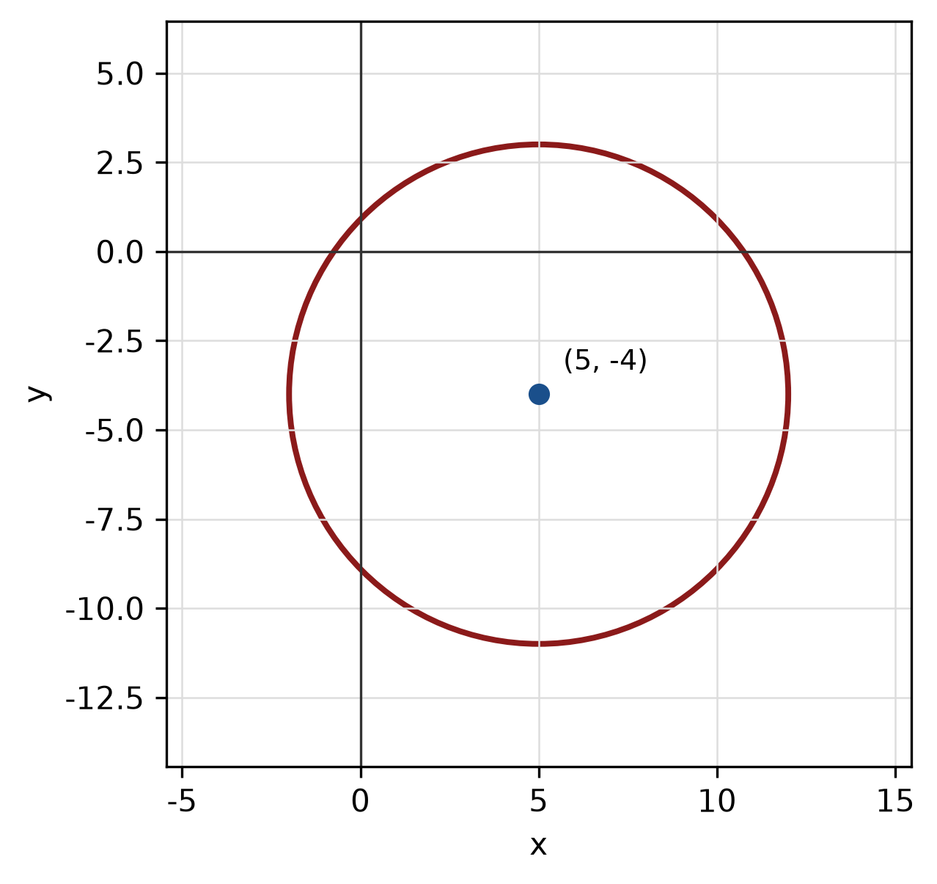
Figure: circle.
QUESTION 3
a) Write y = x²/4 - x/2 - 19/4 in standard form. Hence state the vertex, focus and directrix, and sketch the parabola.
(5 marks)
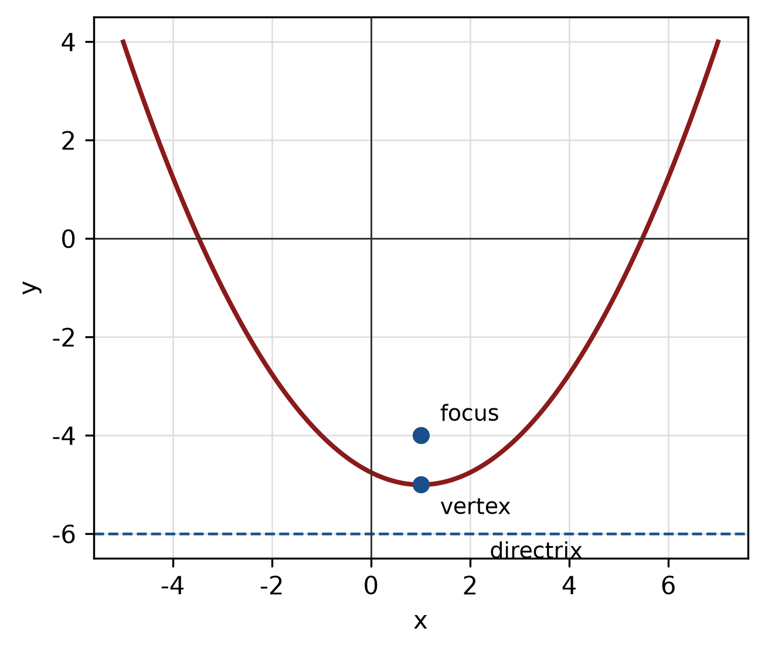
Figure: parabola.
b) Find the standard equation of the parabola with focus (1, 6) and directrix y = 4. State its vertex.
(5 marks)
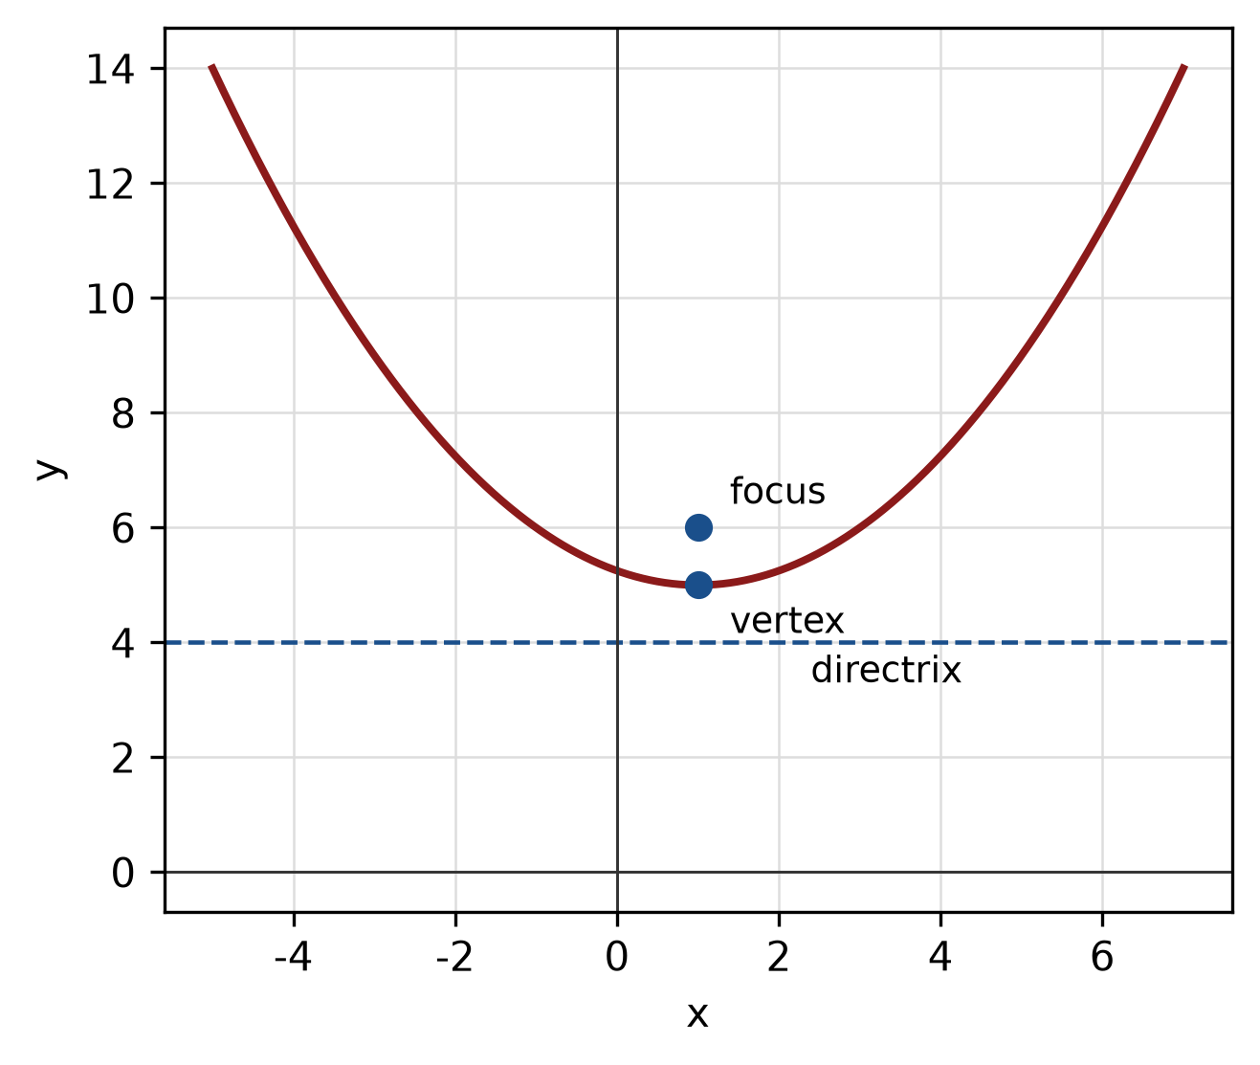
Figure: parabola with focus and directrix.
c) Sketch the parabola (x + 3)² = 4(y - 5). Label the vertex, focus and directrix.
(5 marks)
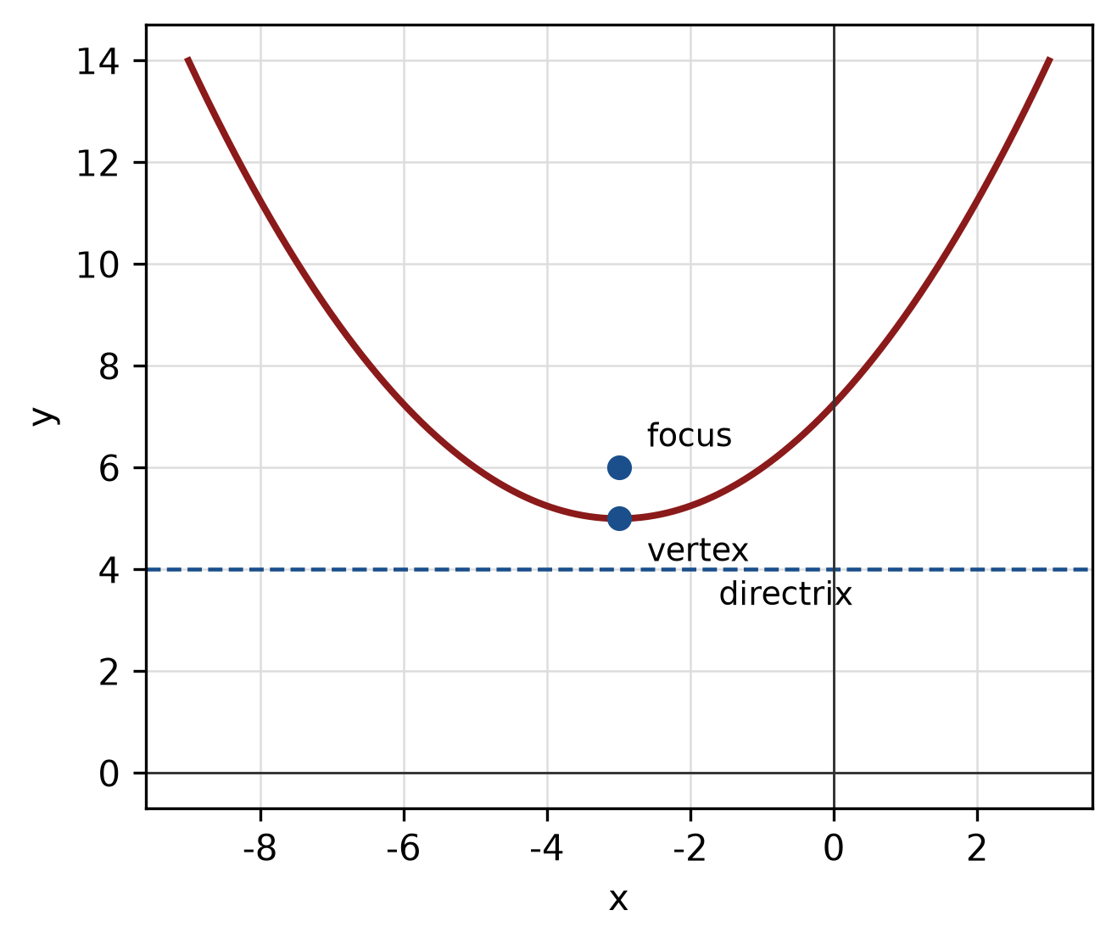
Figure: parabola.
END OF QUESTION PAPER

APPENDIX 1
Formula sheet (as supplied with the paper).
sin² A + cos² A = 1 | tan² A + 1 = sec² A
sin(A + B) = sin A cos B + cos A sin B | tan 2A = 2 tan A / (1 − tan² A)
cos(A + B) = cos A cos B − sin A sin B | Arc length, s = rθ
tan(A − B) = (tan A − tan B) / (1 + tan A tan B) | Area of sector = ½r²θ
cos 2A = cos² A − sin² A | a / sin A = b / sin B = c / sin C
cos 2A = 1 − 2sin² A = 2cos² A − 1 | a² = b² + c² − 2bc cos A
sin 2A = 2 sin A cos A | Area of triangle = ½ab sin C

